Scrum Artifacts
Recall back to the Agile Manifesto, that you value Individuals and Interactions over Processes and Tools. However, you also are implementing a management framework in which you are pursuing constant improvement. So you'd have a goal of determining metrics to guide your improvement strategies, without burdening the team with additional processes and tooling. Scrum artifacts provide just that; minimal and lightweight metrics and reporting to inform the team of their productivity, without slowing the team down.

User Stories
To avoid miscommunication, Scrum describes a standard format for documenting a task. User Stories are tasks which are written from the perspective of the user. This format aids the team in quickly understanding what the intent of the request is and who it benefits.
The typical User Story follows this format: "As a ___ I need ___ to ___ "
Examples:
User Story
- As a user, I need a tooltip describing what a post is
- As a user, I need to be able to create a post to share my opinion with the world
- As an administrator, I need to be able to remove posts which would endanger another user
- As a cashier, I need to be able to swipe a credit card for payment
By leveraging this consistent format, the team can see the desired functionality and the scope of the requests from a user's perspective. This helps you to capture the value that you are offering the customer and focus on delivering it quickly and accurately.
The product owner may also include acceptance criteria in the description of the User Story to indicate some of the more subtle details.
User Story
- "As an administrator, I need to be able to remove posts which would endanger another user."
  - should not be accessible by standard users
  - should prompt the user for confirmation on deleting a post
  - should offer a link to suspend an account for repeat offenders

Story Points
Estimating the time to complete a development task has always been challenging. A request that takes you 4 hours may take another developer 16 hours, and it is incredibly common to overestimate or underestimate technical work grossly.
Scrum recognizes this and offers an alternative in the form of Story Points. Story Points are a means for you to describe the complexity of the work to be done, without relating it to working hours, which has proven to be a highly inaccurate way of setting expectations for completion. Scrum best practices call for you to assign each story some points which are intended to describe the relative complexity of the task.
To understand relative complexity, time to look at an example. For the moment, assume that your options for points (complexity) are: 1,2,3,5,8,13... You will learn more on this later.
Say you want to assign some story points to your previous stories:
User Story | Story Points
As a user I need a tooltip describing what a post is | ???
A Tooltip is pretty trivial, so you would assign this one a Story Point of 1 as your lowest complexity. What do you think would be next?
User Story | Story Points
As a user I need a tooltip describing what a post is | 1
As a user I need to be able to create a post in order to share my opinion with the world | ???
Creating a post seems pretty challenging. You need a UI to allow the user to enter the post, you'd need to store the post, and you'd need to retrieve the post for display. There is a bit of work involved here, but it's also a standard feature, so it's not too concerning.
To assign it a Story Point, you compare it to your history of points, and you score it based on its complexity relative to prior tasks. Your prior task is a Tooltip, with a point score of 1. Well, this story is more complex, so you assign it a higher value. There is no precise science here since you don't yet have much of a history of story pointing. Just call it an 8!
User Story | Story Points
As a user I need a tooltip describing what a post is | 1
As a user I need to be able to create a post in order to share my opinion with the world | 8
As an administrator I need to be able to remove posts which would endanger another user | ???
Ok, your next Story involves deleting a post. After giving this some thought, it seems like it would be less complex than creating a post, since it would simply require the UI and the functionality to delete the record in the database. When applying points to this story, you again look to your history. It's more complicated than your Tooltip with a value of 1, and you've determined that it's slightly less complex than creating a post with a value of 8. If you reference your sequence of potential point scores (1,2,3,5,8,13,...), you will probably conclude it is most accurately described as a 5 when compared to the other two.
User Story | Story Points
As a user I need a tooltip describing what a post is | 1
As a user I need to be able to create a post in order to share my opinion with the world | 8
As an administrator I need to be able to remove posts which would endanger another user | 5
As a cashier I need to be able to swipe a credit card for payment | ???
Now for your last user story, enabling credit card swiping for payment processing. This is a pretty scary User Story, time to consider what must be done.
- A UI to accept the swipe
- Integration with a physical swiping device
- Integration with a payment service or bank
- Security measures to ensure that you are not exposing sensitive database
Wow, this one gets scarier the more you think about it. This is easily five times more complex than your most complex story (Creating a post). The story points for this story might be around 54 (or higher!).
This is an excellent example of the need to break down a story into smaller stories. If a story cannot be completed within a single sprint, you must break it down into smaller attainable stories. Therefore you would then begin to break this story into smaller tasks and point each of those individually — your bulleted list above might be a good starting point.
As a general guideline, any story exceeding a point value of 13 should be broken down.

The Fibonacci Sequence for Pointing
The sequence used above (1,2,3,5,8,13...) is referred to as the Fibonacci sequence. In the Fibonacci Sequence, each value represents the sum of the prior two values (e.g. 3 = 2 + 1, 13 = 8 + 5, etc.)
So why do you use this sequence instead of values between 1-10? Well, it is often difficult to discern between the complexity of 7 and 8 for example. The Fibonacci Sequence provides a natural separation of values to help you collectively classify them. It is more likely that you'd agree that a story is a 5, 8 or 13 as opposed to a 5,6,7,8,9,10.
When teams are assigning story points, they should do it as a team effort. The team should vote on what they believe the point value to be. If there is disagreement, then the highest and lowest voters should voice their reasoning, and a re-vote should occur.

Backlog
The Backlog refers to the queue of pending User Stories. This is the wishlist of features from the Product Owner, and may also include architectural tasks or technical debt cleanup as recommended by the team.
There are two Backlogs in a Scrum Team:

Product Backlog
The Product Backlog includes all known User Stories and feature requests. It should span well beyond the scope of the current sprint. The Product Backlog is where the team will pull User Stories from when planning a sprint.

Sprint Backlog
The Sprint Backlog contains the list of all User Stories which are committed to within the current Sprint.

Swim Lanes
During a Sprint, the team manages the Sprint backlog through a concept referred to as Swim Lanes. Each User Story within the Sprint should be classified as one of a few simple statuses: To-Do, Doing, Done. This is in stark comparison to traditional project management where dozens of potential statuses confuse the state of a task. User Stories and swim lanes are often represented on a physical board using sticky notes; however many software-based solutions are available to simulate the same process.
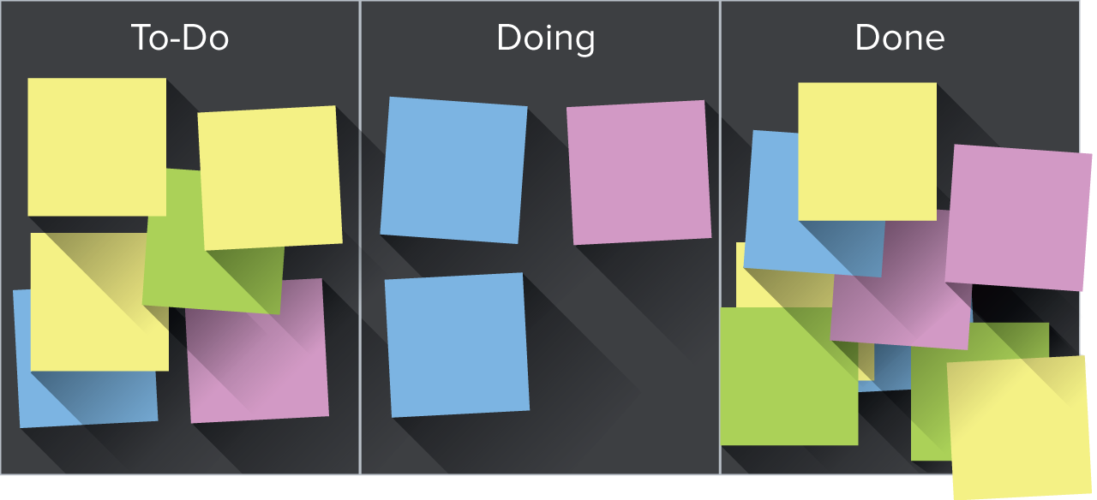

Burndown Chart
When Measuring mid-sprint progress, Scrum teams refer to the Burndown Chart. Burndown represents the trend towards completion of the stories committed to within the sprint backlog. During the sprint, this chart gives clarity to the pace and health of the sprint in regards to completing the commitment on time. This chart graphs a trend line starting on its y-axis as the total number of story points in the sprint and approaches zero as the stories are completed.
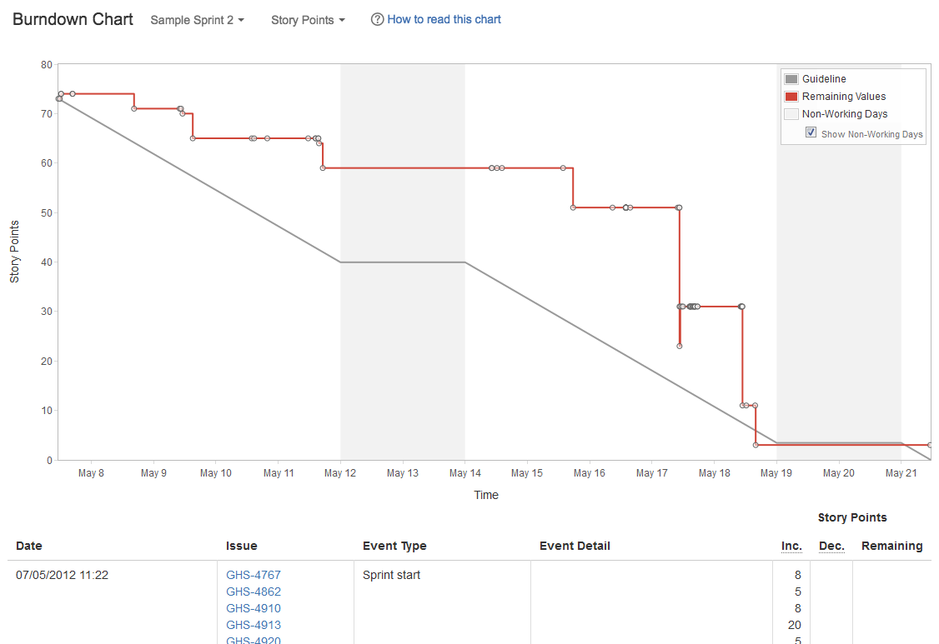

Velocity Chart
You may be asking yourself, "How does the team know how much to commit to within a sprint without overreaching?" The answer to that question is through understanding the team's Velocity. The velocity of the team, essentially, is determined as the average story points completed per sprint. As an empirical process, Scrum looks historically at the team's performance when setting reasonable expectations. That is to say that if the team is averaging 80 story points per sprint, the team would typically feel comfortable committing to 70-90 points in the coming sprint. Velocity is the true measure of the team's productivity and is based on historical performance instead of opinions.
A multi-sprint velocity chart:
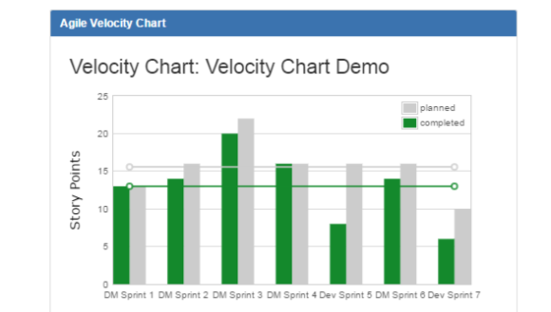

Definition of Done (DoD)
Another important aspect of Scrum is ensuring that the team collectively drives stories through to completion. As an iterative process, there is always opportunity to extend or improve features in later sprints, but, as you are focused on potentially shippable increments, you need to be clear on what done means.
Have you ever been in a situation where you disagreed on whether a particular task is done or not? This is a widespread occurrence in Software Development. Does done mean coded? Does done mean tested? Does done mean live in production?
Although Scrum does not define done for us, the framework requires that teams discuss and agree upon a definition of done to be agreed upon and adhered to when using the term.

